The shot heard ‘round the world.

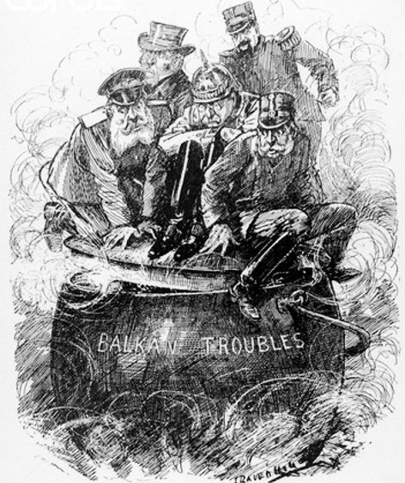
1. Identify and explain each of the major causes of WWI.
2. Who or what do you think is MOST to blame for the outbreak of war? Some people have argued that war was probably inevitable. Do you agree with this? Why?
3. Why would the Triple Entente have been particularly threatening to Germany? Look at the map on page 68.
4. What were the demands that Austria-Hungary made of Serbia after the assassination of Archduke Franz Ferdinand? Explain Serbia’s response.
5. Explain Britain’s entry into the war. Explain Canada’s.
5. Explain the Schlieffen Plan. Why did it not work as planned?
6. Identify each of the following terms:

Sam Hughes
Valcartier camp
Arms Race
Black Hand
Balkans
Robert Borden
Ross Rifle

