Post-Colonial Assignment
As you are reading the book, it is your responsibility to collect significant quotations that relate to either the:
- Protagonist
- Antagonist
- Central Supporting Characters
- Setting
- Major Plot Events
After collecting 3-5 quotes on each of the topics above, you will use them to depict (draw) the character, setting or plot event (keep in mind that you do not need to have a drawing for antagonist or supporting character, and can instead have more setting or plot drawings).

Please make sure that each quotation is properly cited with the author’s last name and the PAGE NUMBER where it was taken from. I was unable to do that since I took the quotes from an online source.

In total, you should have 5 drawings with around 5 quotes for each. This will be handed in along with your final artistic assignment.

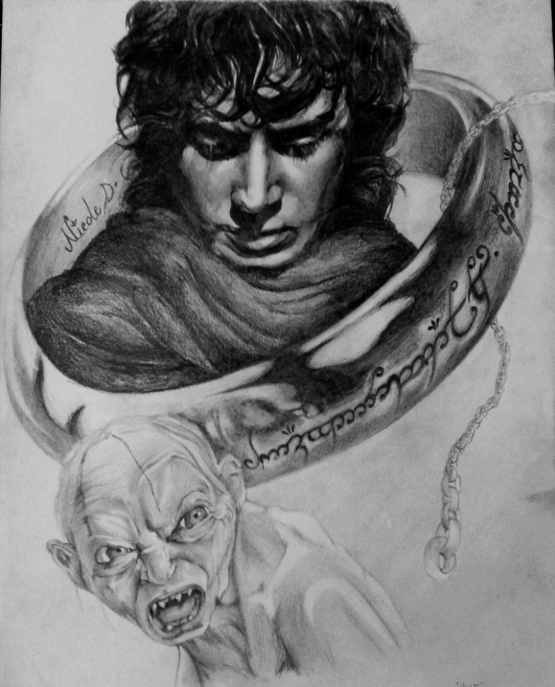
“As for the Hobbits of the Shire, with whom these tales are concerned, in the days of their peace and prosperity they were a merry folk. They dressed in bright colours, being notably fond of yellow and green; but they seldom wore shoes, since their feet had tough leathery soles and were clad in a thick curling hair, much like the hair of their heads, which was commonly brown. Thus, the only craft little practised among them was shoe-making; but they had long and skilful fingers and could make many other useful and comely things.” (Chapter 1 – Concerning Hobbits)
“He took off his party clothes, folded up and wrapped in tissue-paper his embroidered silk waistcoat, and put it away. Then he put on quickly some old untidy garments, and fastened round his waist a worn leather belt. On it he hung a short sword in a battered black-leather scabbard. From a locked drawer, smelling of moth-balls, he took out an old cloak and hood.”
“Things would have gone ill with Sam, if he had been alone. But Frodo sprang up, and drew Sting from its sheath. With his left hand he drew back Gollum's head by his thin lank hair, stretching his long neck, and forcing his pale venomous eyes to stare up at the sky.”

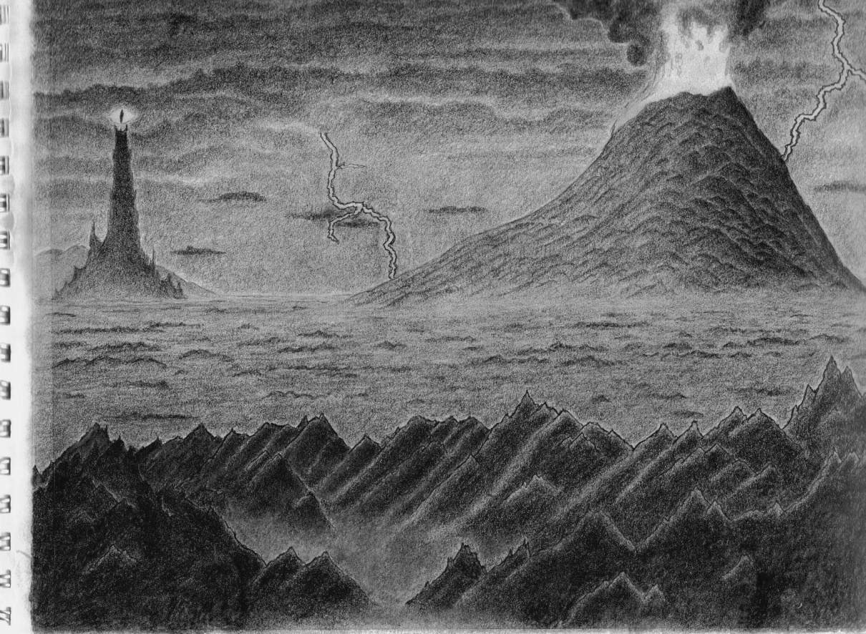
That name the hobbits only knew in legends of the dark past, like a shadow in the background of their memories; but it was ominous and disquieting. It seemed that the evil power in Mirkwood had been driven out by the White Council only to reappear in greater strength in the old strongholds of Mordor.
'Hush!' said Gandalf from the shadows at the back of the porch. `Evil things do not come into this valley; but all the same we should not name them. The Lord of the Ring is not Frodo, but the master of the Dark Tower of Mordor, whose power is again stretching out over the world! We are sitting in a fortress. Outside it is getting dark
`I was the herald of Gil-galad and marched with his host. I was at the Battle of Dagorlad before the Black Gate of Mordor, where we had the mastery: for the Spear of Gil-galad and the Sword of Elendil, Aiglos and Narsil, none could withstand. I beheld the last combat on the slopes of Orodruin, where Gil-galad died, and Elendil fell, and Narsil broke beneath him; but Sauron himself was overthrown, and Isildur cut the Ring from his hand with the hilt-shard of his father's sword, and took it for his own.'
'I wonder if this is a contrivance of the Enemy,' said Boromir. "They say in my land that he can govern the storms in the Mountains of Shadow that stand upon the borders of Mordor. He has strange powers and many allies

