POLITICAL CARTOON

Political cartoons are a pictorial editorial and artistic social commentary. They provide a chance to express social and political views creatively, beyond the boundaries of the written word. Political cartoons can be used to influence viewers or make them think about the current issues of the day. They can be used to:
(1) promote the status quo (support what is going on);
(2) raise awareness of social concerns;
(3) motivate people to seek change.

You live in Totalitaria and are deeply concerned with ______________________ (issue).
You happen to know a man who owns a printing press and believe the public must understand this issue better. It just so happens that most people cannot read, so you decide to create a political cartoon instead so that the masses will be better informed of the issue.

Criteria:
The political cartoon must:

- be produced on an 8x11 sheet of paper.
- be hand-drawn as neatly as possible.
- be an original creation.
- take one issue from the reading to either: (1) promote the status quo; (2) raise social concerns;
OR (3) motivate people to seek change.
- be coloured or appropriately shaded.
- use appropriate symbols, dimensions, exaggerations, labeling, analogies, irony, etc. (the techniques) to convey the message.
- be accompanied by half to one page summary (12 font double spaced) of your cartoon that explains the message(s) and how you used certain techniques to convey the message(s).

Due Date: ________________________________
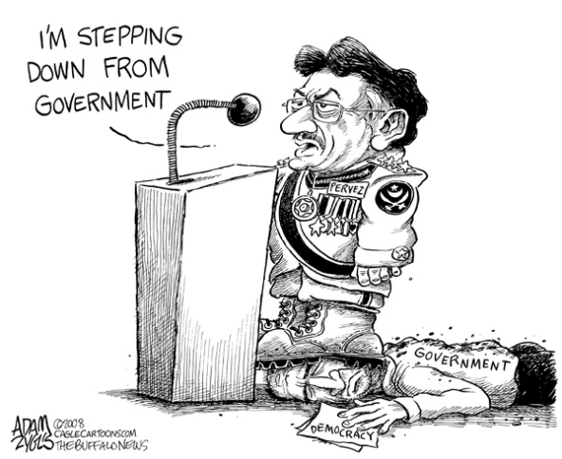

Political Cartoon: Rubric Student:

Criteria | Level 0 | Level 1 | Level 2 | Level 3 | Level 4
Organization & Preparation (A) | The political cartoon appears very messy &/or disorganized. | The political cartoon appears to have been hastily created and appears messy or disorganized. | The political cartoon is of fair quality and seems rushed. | The political cartoon is of good quality and it is apparent that the student spent some time. | The political cartoon is of excellent quality and it is apparent that the student spent time in preparing it.
Knowledge & Concept of the Topic (K) | The political cartoon does not demonstrate an understanding of the issue. | The political cartoon demonstrates that the student is still struggling to understand the issue. | The political cartoon demonstrates recognition of an issue but not a clear understanding. | The political cartoon demonstrates a good understanding of an issue. | The political cartoon demonstrates an insightful understanding of an issue.
Visual Expression of Ideas (T) | The political cartoon does not demonstrate any symbolism or any of the techniques involved in delivering a message. | The political cartoon demonstrates very little symbolism or very few of the techniques involved in delivering a message. | The political cartoon demonstrates some symbolism and incorporates some techniques involved in delivering a message. | The political cartoon demonstrates symbolism and incorporates good techniques involved in delivering a message. | The political cartoon is rich with symbolism and incorporates many of the techniques involved in delivering a message.
Written Communication (C) | Very limited explanation of how techniques are used. | Limited explanation of how techniques are used. | Some explanation of how techniques are used. | Good explanation of how techniques are used. | Thoughtful & clear explanation of how techniques are used.

