Home Front Homework

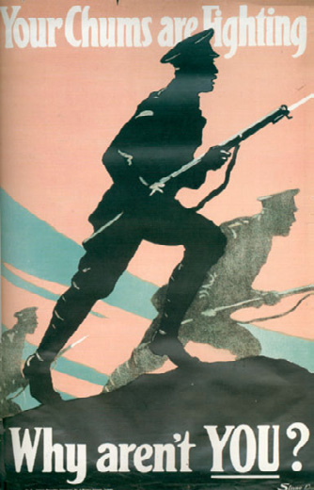
Propaganda Poster Analysis

Analyze the propaganda posters found from the online
link

- Choose 2 of the 4 posters to analyze.
- Answer question 1.
- Answer questions 2-5 for each of the posters you
choose.
- Answer question 6.

“Enemy Aliens” Reading and Questions

Answer the following Questions:

- Why had many German, Austrian, Hungarian, and Ukrainian people come to Canada?

- How were these people viewed during the war?

- Define the War Measures Act

- Describe what would happen to you if you were considered an “enemy alien”.

- What were conditions like in the internment camps?

- Explain censorship.

