**Reading Extract**

Read the passage below in detail. If you print it out, make sure you gloss over the text to add details related to characterization, plot, setting, theme and importance devices such as symbolist, simile, metaphors, etc.

If you choose to do this online, use the “Ctrl + Alt + M” command prompt on the keyboard to add your comments.

If you have any questions, feel free to ask me or e-mail me at mr.heidarbozorg@gmail.com

**Little Women**

By Louisa May Alcott

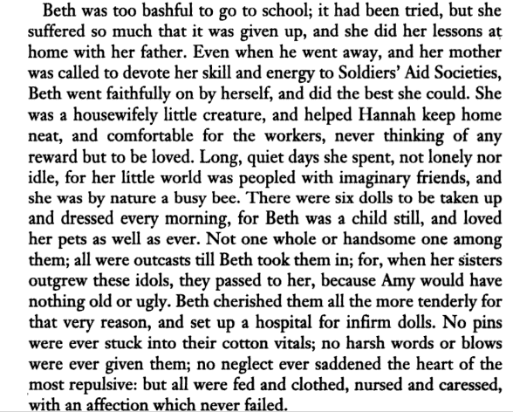

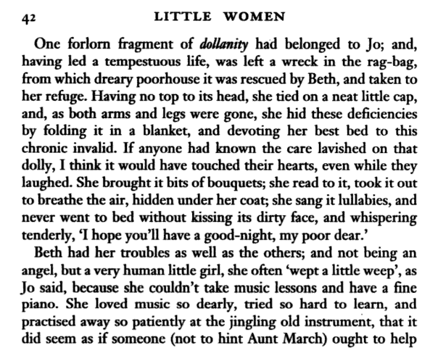

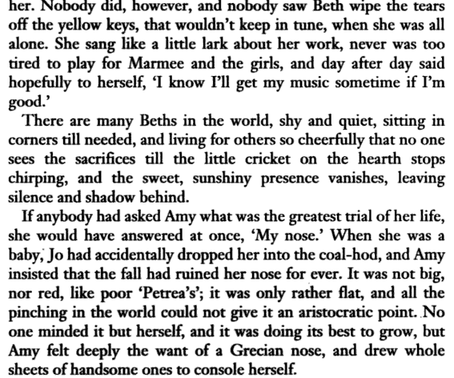

**Key Questions**

**Once you are done with the reading, answer the questions below. Make sure each answer is in paragraph format and that you use specific examples to support each response.**

1. Explain the setting depicted in the passage. How is it important to the plot?
2. What is the importance of “social class” for the plot and characters?
3. Explain the quote: “There are many Beths in the world, shy and quiet, sitting in corners till needed, and living for others so cheerfully that no one sees the sacrifices till the little cricket on the hearth stops chirping, and the sweet, sunshiny presence vanishes, leaving silence and shadow behind.” How does it relate to modernism?
4. Research the background of the novel and the author. Explain how the biography of the author and the era it was written, may have influenced different aspects.
5. Make a couple intertextual connections between the text and either another book (passage), scene from a TV show or movie, or from your personal life / news.