Diagnostic population quiz
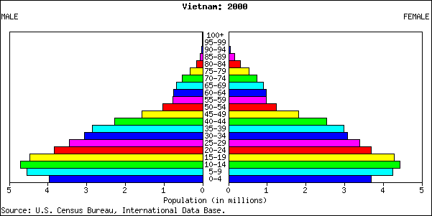
In which phase of the demographic transition model is this country? .
What does the pyramid tell us about birth rates?

Starting pop. | 9 900 000
Births | 360 000
Deaths | 451 000
Infant deaths | 1 800

Birth rate:
Death rate:
Rate of natural increase:
Rate of infant mortality:

Name:

