Introduction to Storyboarding eNote
Name |  | Date

VERBAL DIALOG

- Create an outline of the story by writing down the main points of action, listing action as opposed to
- The verbs
- Action is what drives a story.

Example:

On a beautiful day Sally works in her garden.
Jonathan enters, looking sad. He tells Sally that they can no longer be friends.
Sally, now angry, stomps off.
Jonathan, looking cautiously around, plucks Sally’s most prized rose from the garden, hides it in his coat, and runs from the garden.

THE BOARD

- A storyboard is the visual outline of the story. It will look
- It is used to tell the visual story and give an idea of how the film should look. Within each frame decide what shots to use, where the

STORYBOARDING

- First Step
  - Visualization process and
- Storyboards serve two main purposes;
  - to allow the film maker to
  - to provide the clearest
- Storyboards convey two kinds of information;
  - a description of the
  - a description of the staging, camera direction, and the movement of any elements in the shot.

Examples:

- Can be very easy
- This is the basic method, written description and

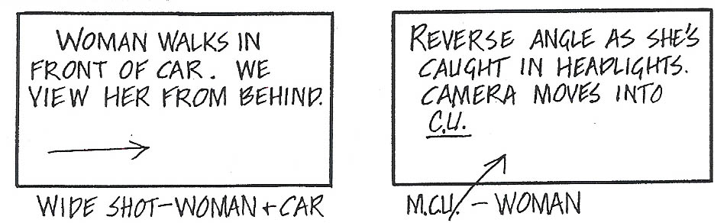

Drawings can be used to clearly show

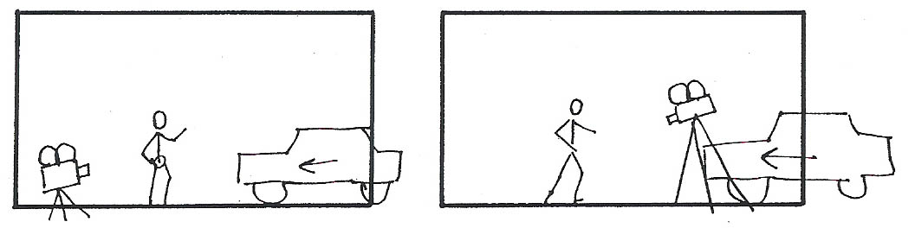

Stick people can be very informative; they convey

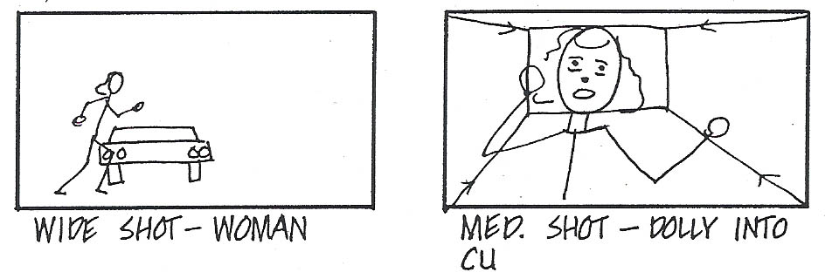

Arrows drawn with perspective can show
