|  |  |  |  |
| --- | --- | --- | --- |
| **A Brief History of Television** | | | |
| Name |  | Date |  |

**Introduction**

|  |
| --- |
| * Few inventions have had as much effect on |
| * Before 1947 the number of homes |
| * By 2010, 99 percent of Canadian homes had |
| * Unlike many other inventions throughout history, |

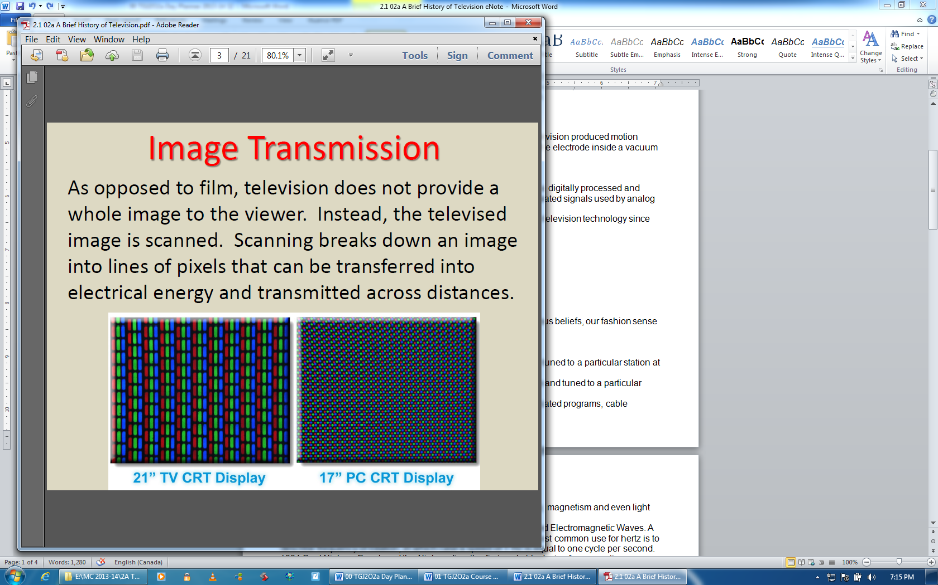**Image Transmission**

|  |
| --- |
| As opposed to film, television does not provide a whole image to the viewer. Instead, the televised image is scanned. Scanning breaks down an image into lines of pixels that can be |



**Cathode Ray Tube**

|  |
| --- |
| As opposed to film, with it’s mechanical progression of images, television produced motion pictures through a Cathode Ray: |

**Digital and HDTV**

|  |
| --- |
| Digital Television (DTV) is the transmission of audio and video by a digitally processed and encoded signal |
| It is an innovative service that represents a |

**Television and Culture**

|  |
| --- |
| Television Is Important Because: |
| * We spend |
| * It helps |
| * It provides |
| * It is the primary |
| * It shapes our |

**Television Ratings**

|  |
| --- |
| * Rating is the percentage of all homes equipped with |
| * Share is the percentage of homes in which the |
| * A.C. Nielsen collects ratings for network and |

**The Invention of Television**

|  |
| --- |
| * **1860-1865 James Maxwell:** His equations theorized that electricity, |
| * **1880-1885 Heinrich Hertz:** Proved Maxwell’s theories and identified Electromagnetic Waves. A Hertz (Hz) Unit can be used to measure any periodic event; the most common use for hertz is |
| * **1884 Paul Nipkow:** Developed the Nipkow disc, the first workable device for |

**Early Television Timeline**

|  |
| --- |
| 1900: The word “Television” is first used. |
| 1922 to 1927: The 'first' generation of TVs were not entirely electronic. Experiments with Mechanical scanning disc systems began. The TV had a motor with a spinning disc and a neon lamp producing a picture. |
| 1927 to 1928: First Mechanical TVs sold to the public. The period before 1935 was called the "Mechanical Television Era". This era was |
| 1928 to 1935: Early experiments were performed using a system called All-Electronic |
| 1935 to 1941: An experimental form known as Electronic TV begins in:. |
| 1941: Electronic Black and White Television begins broadcasting in the US. First two licensed TV stations were New York’s |

**Early Television Developments**

|  |
| --- |
| * 1923 - Vladimir Zworykin, working for Westinghouse, demonstrated his Iconoscope Tube, |
| * 1927 - Philo T. Farnsworth completed a |
| * 1929 - David Sarnoff lured Zworykin to RCA where he developed the Kinescope, |
| * Inventors in several countries including England, Japan and Russia, claim to |
| * 1939 - The Words Fair in New York, RCA made |

**Early Television**

|  |
| --- |
| * David Sarnoff of RCA built one of the first commercial television stations in 1932, with the transmitter in the Empire State Building, |
| * Franklin D. Roosevelt became the first president to appear on television when he |
| * Early TV sets did not sell because they were very expensive, there wasn’t |

**Development of Technical Standards**

|  |
| --- |
| * In the early days of TV, manufacturers would profit if their patents |
| * Some wanted black and white to be the standard, while others were working on colour and wanted |
| * Other patents involved different lines of resolution, (rows of lit pixels), that |
| * In 1941, the US government and industry agreed that television would present black and white pictures with 525 lines of resolution moving at a |

**Broadcast Television**

|  |
| --- |
| * Technically all broadcast television stations are local because signals that broadcast from a station’s transmitter will only be seen up to 80KM from the transmission point unless |
| * About one quarter of all television stations in North America are public broadcasting stations supported by |
| * About half of all stations are VHF, or Very High Frequency, and operate on a channel from 2 through 13. The other half are UHF, or Ultra High Frequency, |

**Post War Growth**

|  |
| --- |
| **World War II Stops TV’s Growth**  Most of the engineers in television joined the military and developed radar, sonar, |
| **Post-War Development**  In the early 1940s audiences were excited to see any video so the industry broadcast anything available including talentless talent, live shots of a sunset and even test patterns. By 1948, TV sales increased by |
| * 1948 to 1958 was a time of unusually good dramatic programming. |
| * Quality dramas were needed to attract wealthy, educated viewers |
| * Most television dramas were performed live because videotape recording had |
| * In the fifties, more TV sets (70 million) were sold than children born |
| * In 1952 there were 108 TV stations. Ten years later there were 541. Today there are about |
| * The big three networks – ABC, CBS and NBC – dominated programming. On any given night more than. |
| * The first issue of TV Guide appeared |

**The Entrance of the Movie Studios**

|  |
| --- |
| * In 1954 Walt Disney was the first studio leader to associate his name with a television program. Disney saw the possibilities of TV for promoting his Disneyland theme park and |
| * After Warner Brothers began producing the western “Cheyenne” for ABC in 1955, all the major film studios started |

**The Future of TV**

|  |
| --- |
| * Corporate mergers continue to reduce the number of “voices” |
| * Digital television (HDTV) |
| * Reality programming becomes TV's |
| * TV programming becomes available through |

**Controversies**

|  |
| --- |
| * To reach the greatest possible audience, most television programs are |
| * Most critics agree that TV entertainment is too violent – particularly when the violence |
| * Extensive research into television indicates that exposure to televised material |