Reading Extract

Read the passage below in detail. If you print it out, make sure you gloss over the text to add details related to characterization, plot, setting, theme and importance devices such as symbolist, simile, metaphors, etc.

If you choose to do this online, use the “Ctrl + Alt + M” command prompt on the keyboard to add your comments.

If you have any questions, feel free to ask me or e-mail me at mr.heidarbozorg@gmail.com

The Lord of the Rings – The Fellowship of the Ring

By J.R.R. Tolkien
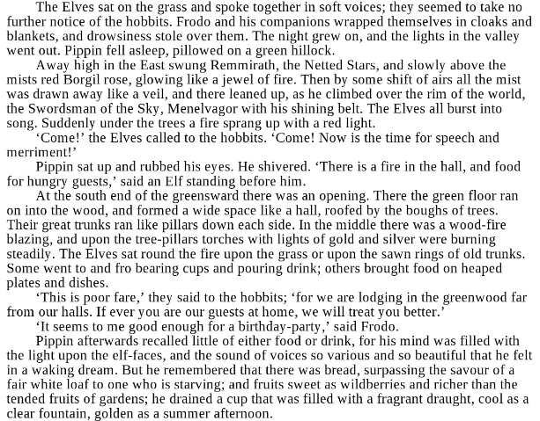5

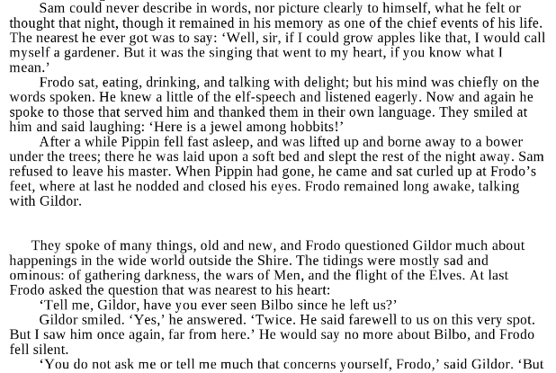
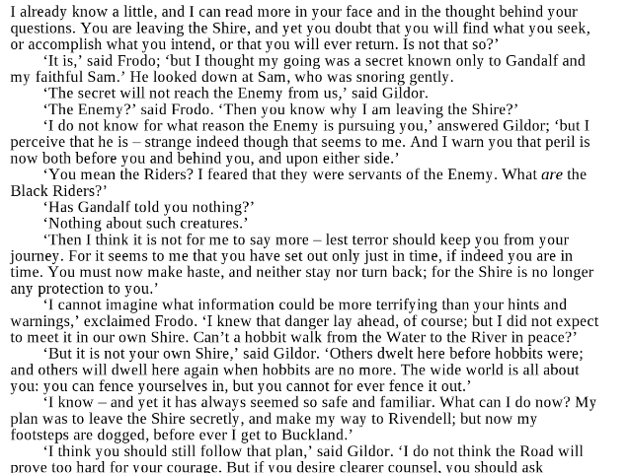
Key Questions
Once you are done with the reading, answer the questions below. Make sure each answer is in paragraph format and that you use specific examples to support each response.
- Continue the rest of Gildor’s speech and the response from Frodo. Have several lines of dialogue between them that complement the story.
- How would you describe the character interactions? Explain the dynamic between each of the main characters.
- Explain the quote: “The wide world is all about you: you can fence yourselves in, but you cannot for ever fence it out.” What theme could this portray?
- Research the background of the novel and the author. Explain how the biography of the author and the era it was written, may have influenced different aspects.
- Make a couple intertextual connections between the text and either another book (passage), scene from a TV show or movie, or from your personal life / news.

