THAMES VALLEY DISTRICT SCHOOL BOARD
Montcalm Secondary School
Communications Technology
Mr. Papini

Writing for TV and Film
Name |  | Date

OBJECTIVES

- Explore techniques for.
- Organize Strategically for
- Understand the
- Survey the Creative Process of

THE IDEA

- Personal
- Events in
- Story
- Copyrighted l
- The Public

THE CONCEPT

Often called the Log Line: a brief summary of a TV/film production providing

For Example: Shakespeare struggles to overcome his writer’s block by seeking a muse and he discovers true love.

The Result:

THE EARLY STAGES OF STORY DEVELOPMENT: The Story Outline

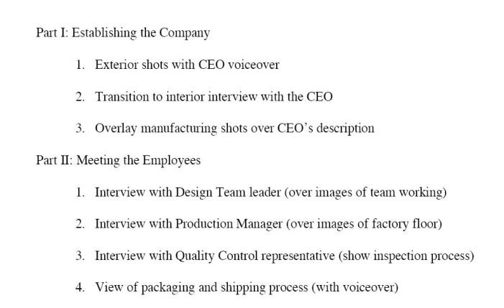 | 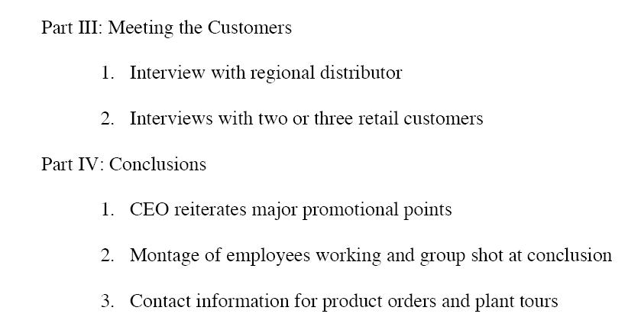

THE EARLY STAGES OF WRITING AND STORY DEVELOPMENT: The Scene Outline
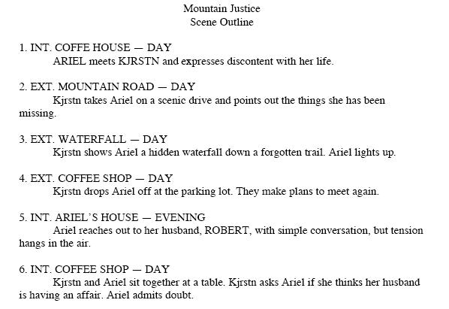

THE EARLY STAGES OF WRITING AND STORY DEVELOPMENT

THE TREATMENT

- A Treatment is a summary of a screenplay for a

- It is written as a

THE TREATMENT: Example

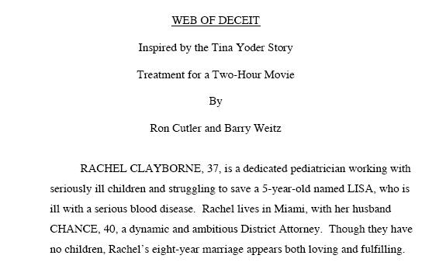
TREATMENT GUIDELINES

- Use Visual and
- Get the reader
- Written in the
- Single-
- Place Line Breaks to show

THE DRAMATIC STRUCTURE

Exposition

Inciting Incident | The conflict that begins the action of the story and

Complications | Rising & Falling Action. The basic conflict is complicated by the introduction of related secondary conflicts, including

Climax or Crisis | The climax, or turning point, marks a change, for better or worse, in the protagonist’s story. If the story is a comedy, things will have gone badly for the protagonist up to this point; now, the story turns and things will begin to go well for him or her. If the story is a tragedy,

Resolution | The comedy ends with a dénouement (a conclusion) in which the protagonist is better off than at the story’s beginning. The tragedy ends with a catastrophe in which the protagonist

CHARACTERS

Protagonist | The Hero or Main Character(s) of the story.

Antagonist | This is the person or persons opposed to, or

Ensemble Cast | An ensemble cast is made up of cast members in which the main actors are given equal amounts of importance and screen time. This is different

Supporting Characters | Individuals in a narrative used to give added

THE CREATIVE PROCESS OF WRITING

- Write your Ideas down.
- How do they look after a few days?
- Share your work with Friends and Seasoned Writers.
- Activate the imagination in Indirect Ways.
- Music is a powerful tool.

BRAINSTORMING

- Look at today’s news and write Three Concepts for Stories based on news articles you review.

- Write a 1 page Treatment inspired by your own life’s experience. Use the format shown in class. How will you get the reader Engaged? Who are the Antagonists, and what Complications do You face? How does the story End?

- Choose one of your favorite films of all time. Identify the Protagonist(s) and Antagonist(s). What is the Inciting Incident? What are some of the Complications? Is the protagonist Successful in his or her journey? What is the Climax of the story?

