THAMES VALLEY DISTRICT SCHOOL BOARD

Montcalm Secondary School

Communications Technology

Mr. Papini

|  |
| --- |
| **Camera Actions** |

**CAMERA SHOTS**

There are several different Camera Shots used in TV and Film Production.

Each Camera Shot is given a name and description for use during *storyboarding*.



**EXAMPLES OF CAMERA SHOT TYPES**

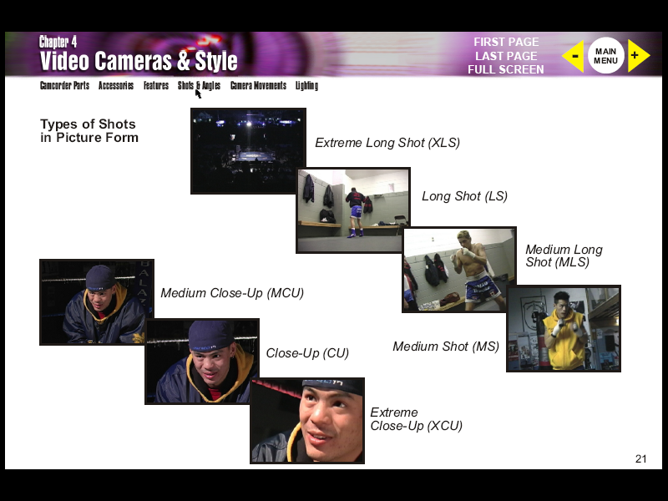

**EXTREME CLOSE UP**

|  |  |
| --- | --- |
| * The subjects |  |
| * Used to make the subject |
| * Can be a |

**CLOSE UP**

|  |  |
| --- | --- |
| * Includes Head and |  |
| * Eyes and facial expression |
| * This is often a reaction shot, one which shows how a |

**MEDIUM CLOSE UP**

|  |  |
| --- | --- |
| * Includes the middle of the |  |
| * This is a good shot when you want |
|  |

**MEDIUM SHOT**

|  |  |
| --- | --- |
| * Includes the subjects’ body from the |  |
| * Similar to our |
| * This is the most |

**MEDIUM LONG SHOT**

|  |  |
| --- | --- |
| * Includes the subject from the |  |
| * Can include two or more |
| * This is useful for showing an actor’s larger |

**LONG SHOT (FULL SHOT)**

|  |  |
| --- | --- |
| * Includes the subject whole body, from |  |
| * Useful shot for |
|  |

**EXTREME LONG SHOT**

|  |  |
| --- | --- |
| * Used to show a whole crowd or an overall view of a |  |
| * This is often called an **Establishing Shot** because |
|  |

**CONTEXT SHOTS**

|  |
| --- |
| These Camera Shots are used to interrupt the current action by inserting a view of something else. This gives the audience |

**CUT AWAY**

|  |  |
| --- | --- |
| * A shot of something other than the |  |
| * Draws attention away from a change or |
|  |

**CUT IN SHOT**

|  |  |
| --- | --- |
| * Shows some part of the |  |
| * Similar to |
|  |

**OVER THE SHOULDER SHOT**

|  |  |
| --- | --- |
| * Looking from |  |
| * Helps to establish the positions of each person, |
|  |

**NODDY SHOT**

|  |  |
| --- | --- |
| * A shot of the |  |
| * Shot and edited |
|  |

**POINT OF VIEW SHOT (POV)**

|  |  |
| --- | --- |
| * Shows a view from the |  |
| * Usually edited in such a way that it |
|  |

**CAMERA ANGLES**



**INTRODUCTION**

|  |
| --- |
| The term **Camera Angle** means slightly different things to different people but it always refers to the way a shot is composed. Some people use it to include all camera shot types, but most professionals use it to specifically mean |

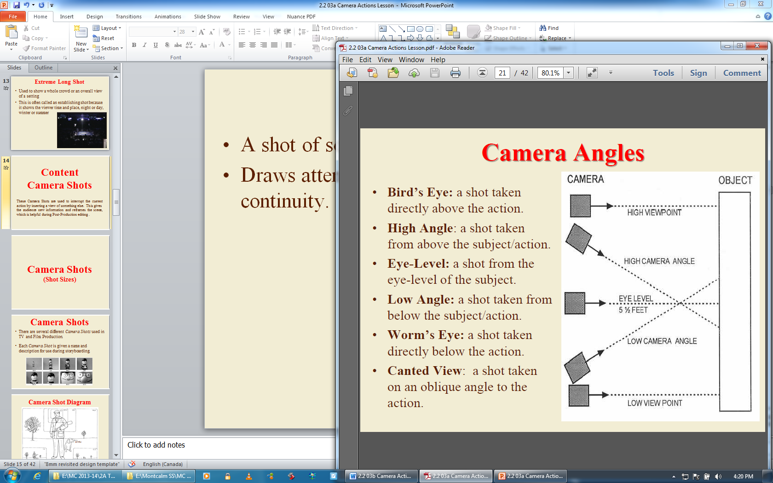

**BIRD’S EYE VIEW**

|  |  |
| --- | --- |
| * Bird’s Eye View: a shot taken directly above the action. |  |
| * What is the effect? |
|  |

**HIGH ANGLE**

|  |  |
| --- | --- |
| * High Angle: a shot taken from above the subject/action. |  |
| * What is the effect? |
|  |

**EYE-LEVEL**

|  |  |
| --- | --- |
| * Eye-Level: a shot from the eye-level of the subject. |  |
| * What is the effect? |
|  |

**LOW ANGLE**

|  |  |
| --- | --- |
| * Low Angle: a shot taken from below the subject/action. |  |
| * What is the effect? |
|  |

**WORM’S EYE VIEW**

|  |  |
| --- | --- |
| * Worm’s Eye View: a shot taken directly below the action. |  |
| * What is the effect? |
|  |

**CANTED VIEW**

|  |  |
| --- | --- |
| * Canted Angle: A shot taken on an oblique angle to the action. |  |
| * What is the effect? |
|  |

**CAMERA LENS TYPES**

|  |  |
| --- | --- |
| **Focal Length**: the distance in millimetres from the optical centre of a lens to the imaging sensor or film. | |
| **Lens Sizes**: A standard lens is 50mm and it gives a | |
| **Wide Angle Lens**: Lenses with focal lengths **less** than 50mm are referred to as wide-angles because | |
| **Telephoto Lens**: Lenses with focal lengths **greater** than 50mm are known as telephotos, and these offer | |
| **/94/e550c3/b43c/3973-FocalLength-diag.gif** | **Diagram of focal length** |

**DEPTH OF FIELD**

|  |  |
| --- | --- |
| The range of distance where | |
| Short focal length | |
| Long focal length | |
|  |  |

**WIDE-ANGLE LENS**

|  |  |
| --- | --- |
| * Short focal length (35 mm or less) produces a wider angle of view. |  |
| * What is the effect? |
|  |

**TELEPHOTO LENS**

|  |  |
| --- | --- |
| * Lens with a long focal length of 75mm or more. |  |
| * What is the effect? |
|  |

**CAMERA MOVEMENTS**

**INTRODUCTION**

|  |
| --- |
| Camera Movements are often used to follow a specific action. They are also used to manipulate and |
| Camera Movements can enhance the emotions of a scene, reveal elements that are off-screen and |

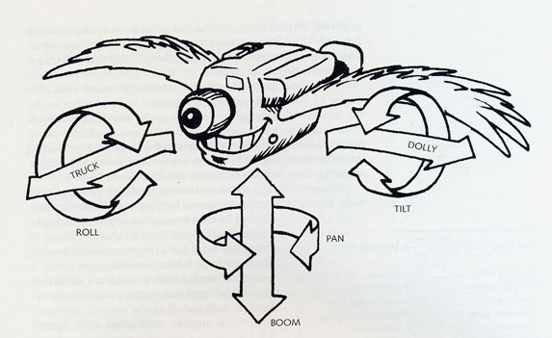

|  |  |
| --- | --- |
| **TILT** | cammot |
| * The camera pivots up and down |

|  |  |
| --- | --- |
| **PAN** | cammot |
| * The camera moves horizontally generally left to right, |

|  |  |
| --- | --- |
| **BOOM** | cammot |
| * The camera is raised or lowered generally |

|  |  |
| --- | --- |
| **TRUCK** | cammot |
| * The camera, mounted on a wheeled tripod is moved from |

|  |  |
| --- | --- |
| **DOLLY** | cammot |
| * The camera, on a wheeled tripod is moved towards or away from |

|  |  |
| --- | --- |
| **ARC** | cammot |
| * The camera on a wheeled tripod or a set of tracks is moved |

|  |  |
| --- | --- |
| **ZOOM** |  |
| * A shot using a lens whose focal length is |
| * This shot is used |
| Shifting to the telephoto range | |
| Shifting to wide-angle | |

|  |  |
| --- | --- |
| **OPERATOR MOVEMENTS** |  |
| **Hand-Held Shots** |
| * Can pan |
| * Hand-held movement is obviously “unsteady”, |
| **Steadicam Shots** |
| * A device which dampens unsteadiness, producing a |
| * Steadicam first used in |