History of Communications
Name |  |  |  |  | Date
Mark | /9K | /0T | /9C | /0A |  | /18 Total

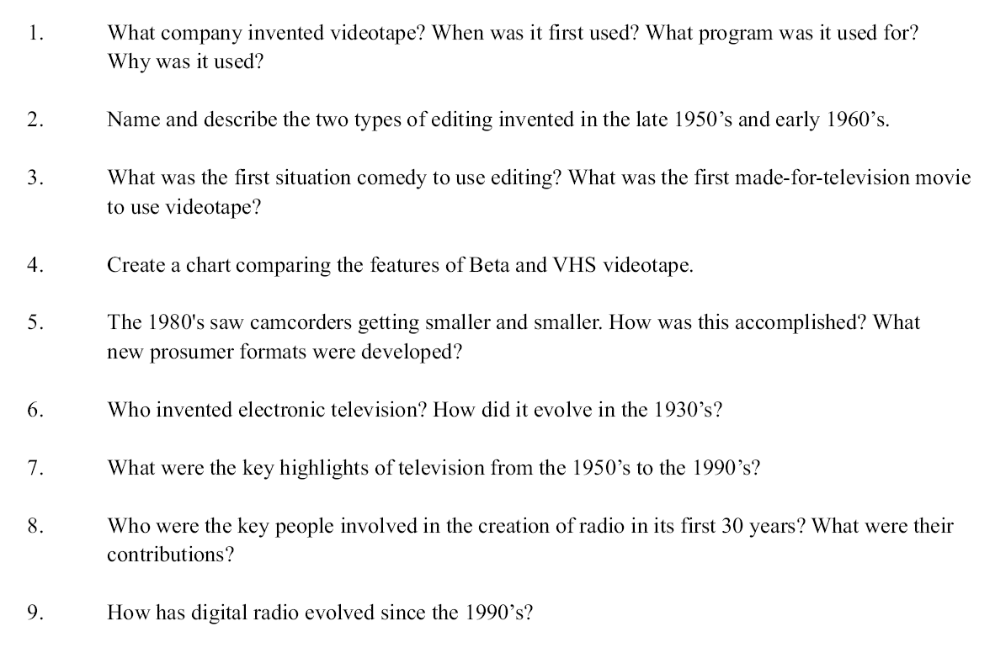

1)

2)

3)

4)

5)

6)

7)

8)

9)

