Applying the Elements & Principles of Design

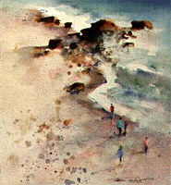
LINE DIRECTION
All lines have direction - Horizontal, Vertical or Oblique. Horizontal suggests calmness, stability and tranquility. Vertical gives a feeling of balance, formality and alertness. Oblique suggests movement and action.
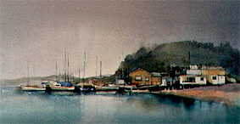

Vertical (Balance)
Oblique (Action)
Horizontal (Calm)
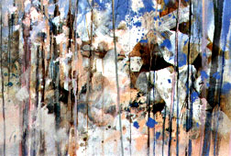

TEXTURE
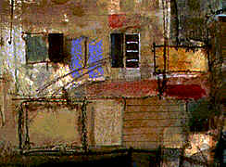
Texture is the surface quality of a shape - rough, smooth, soft hard glossy etc. Texture can be physical (tactile) or visual.

In this design, patches of Japanese rice paper, gesso and thick swipes of soft pastel add a strong three dimensional physical texture.

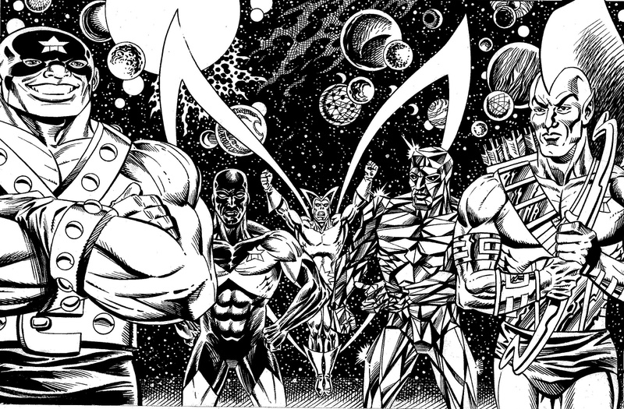

VALUE
Value is the lightness or darkness of a color. Value is also called Tone.

Value Drawing
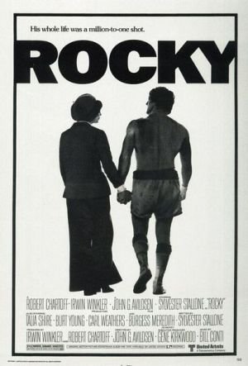

Symmetrical (Formal) Balance
Symmetrical balance is mirror image balance. If you draw a line down the center of the page, all the objects on one side of the screen are mirrored on the other side (they may not be identical objects, but they are similar in terms of numbers of objects, colors and other elements. Sometimes they are completely identical.

Asymmetrical (Informal) Balance
Asymmetrical balance occurs when several smaller items on one side are balanced by a large item on the other side. One darker item may need to be balanced by several lighter items. Although asymmetrical balance may appear more casual and less planned, it is usually harder to use because the artist must plan the layout very carefully to ensure that it is still balanced. An unbalanced design creates a feeling of tension, as if the page or screen might tip, or things might slide off the side, just as the unbalanced balance beam would tip to one side.

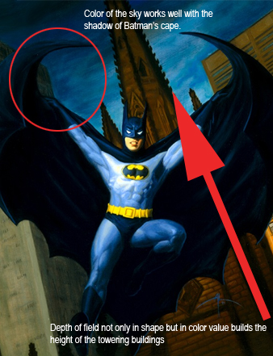

CONTRAST
Contrast is the arrangement of opposing elements and light. The major contrast in an image should be located at the center of interest. Too much contrast scattered throughout an image can destroy unity and make a work difficult to look at.

HARMONY
Harmony in an image is the visually satisfying effect of combining similar, related elements. E.g. adjacent colours on the color wheel, similar shapes etc.
Harmony

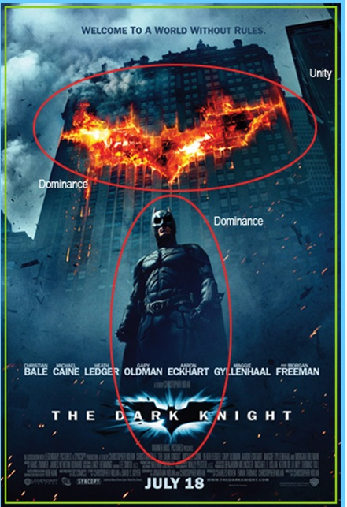

DOMINANCE
Dominance gives a painting interest, counteracting confusion and monotony. Dominance can be applied to one or more of the elements to give emphasis.
UNITY
Relating the design elements to the idea being expressed in a image reinforces the principal of unity.eg. an image with an active aggressive subject would work better with a dominant oblique direction, course, rough texture, angular lines etc. whereas a quiet passive subject would benefit from horizontal lines, soft texture and less tonal contrast.

