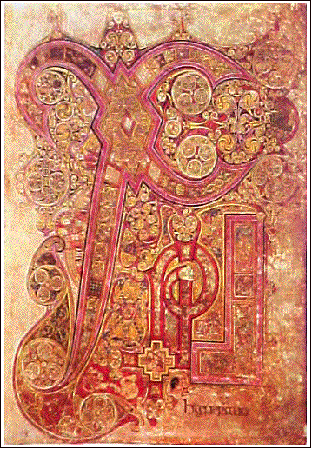
The Origins of Illustration

Modern illustration really began with the invention of the printing press. It was then that it became possible to publish all kinds of information [literary, artistic, scientific, technical] or to decorate and illustrate texts. Since that time, different styles of illustration have developed alongside technical advances in image reproduction. As for illustrative style, the tendencies of each period have coincided with changes in artistic trends, as illustrators have adapted these trends to the graphic styles of their time.
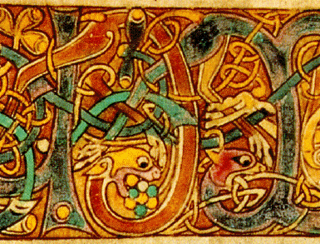

The origins of illustration as we know today can be found in the miniatures that medieval artists used to decorate manuscripts. The illustrations are closer to many present day illustrations than the engraved illustrations of the Renaissance. In fact, as creative works [generally hand painted in watercolours], their effect is very similar to modern techniques of reproduction that give a perfect fusion between text and image. Among the most impressive examples of medieval illustration are the capital letters of the Irish gospels.

These miniatures were often highly detailed works, painted with supreme skill, and were often considered true works of art.

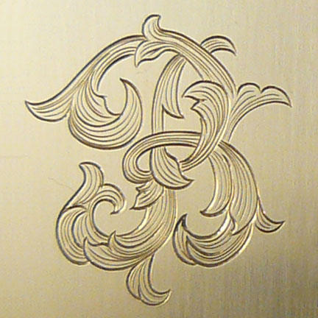
Engraving: A Medium for Broad Dissemination

Before the invention of the printing press, engravings were always made on wood and they incorporated image and text on the same wooden plate. The wood cutting technique did not allow for fine detail. Precision detail was achieved by engraving on metal [from the 16th century onward], which required image and text to be printed separately. This started the fashion for full-page, stand-alone illustrations, and large scale illustrations. This technique heralded the golden age of engravings [realistic portraits, geographical maps, scientific images, etc.] It is a technique that is still used today [dry-point, etching, aquatint, etc.] although nowadays it is usually used by artists other than illustrators. The next great innovation was the lithograph [created in 1798], which allowed colours to be printed. This was unlike previous engraving techniques in which colouring had to be done by hand. The lithograph was the forerunner of modern techniques of photoengraving.

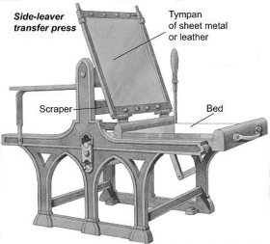


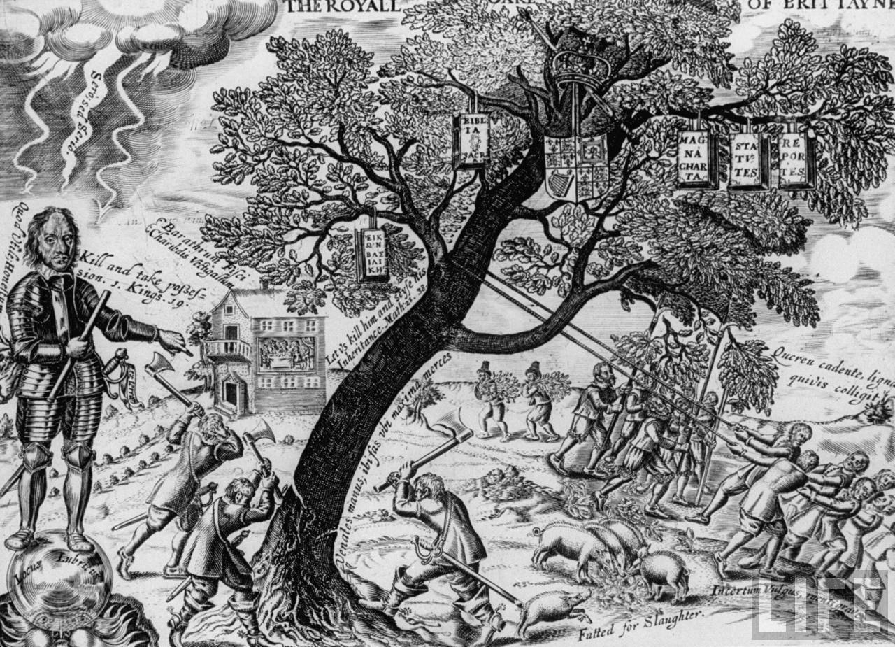
Satirical Illustration

In the 18th century there was a huge boom in book illustration, thanks to the widespread dissemination of illustrated writings by French and British intellectuals. The boom also spread to magazines and periodicals, which were much more concerned with current affairs than with cultural topics. In England the genre of political and social satire was born, which soon became one of the most popular forms of illustration in the modern world.
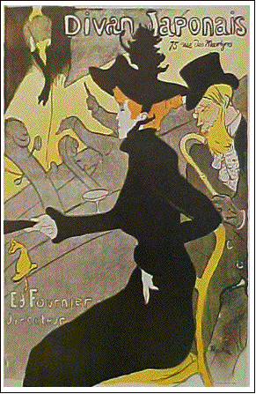

Illustrators in the 19th Century

The second half of the century witnessed the golden age of narrative illustration. It also marked the peak of poster illustration and all types of visual propaganda. Many writers consider the art of poster design to have originated in the middle of the 19th century, at the hands of Honoré Daumier and Édouard Manet. The style of these artists and their imitators would influence the aesthetics of what was to become decorative Modernism. In illustration, this style is distinguished by its stylized forms and influence of Japanese prints, with silhouettes and curved lines that define outlines without giving volume. Modernist illustration is characterized by bright colours, curving lines, everyday subject matter, and a clear suppression of details in favour of flat blocks of colour.

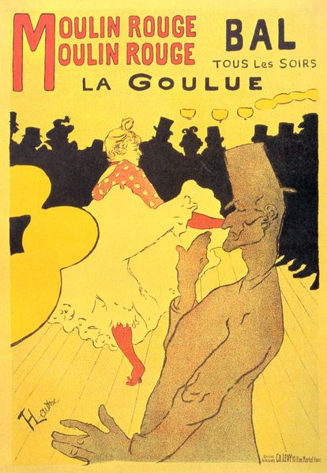
The evolution of illustration towards the end of the 19th century reached one of its high points with the work of Toulouse-Lautrec, many of whose posters are among his most famous works. Bonnard, Gustave Doré and Aubrey Beardsley are the artists whose posters, magazines illustrations, and plates for literary works are hallmarks of the aesthetic of the period that favours spirals and stylized forms of plants and flowers.

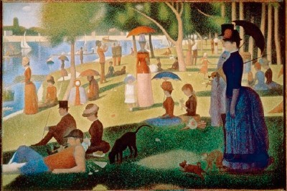

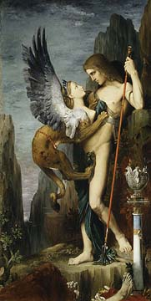
Impressionism and Symbolism

Two vitally important artistic movements co-existed during the final decades of the 19th century: Impressionism and Symbolism. The former favours realism, everyday subject matter, and a rapid sketchy style. In contrast, Symbolism features fantasy based and literary subjects in a style that is highly refined and decorative. Both tendencies were represented by top class illustrators, whose influence can be felt today.

The 20th Century

Prior to the twentieth century, illustrators generally followed the tradition of humorous realism established by the great Victorian artists. The central core of that tradition was rigorous, academic drawing, even when the illustration was decorative, comic, or designed for children. This trend continued into the early decades of the 20th century (and can still be found today).

In the twenties and thirties a certain type of stylization became fashionable among editors and publicists. It sprang from the new vocabulary created by avant-garde painters and sculptors. Commercial expansion after the war gave the more experimental illustrators the chance to work using more modern, expressive forms: this was a type of illustration and design calculated to capture and promote, as well as criticize, the spirit of the new era, the era of mass communication, new media, and consumerism.
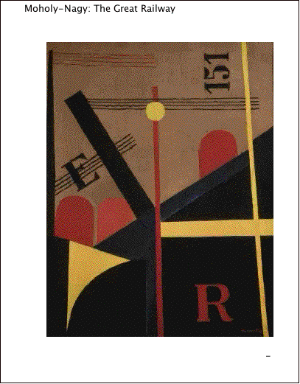
In technical terms, the new type of design dispensed with the obligatory prominence of faithfully figurative drawing. It opened the way for illustrators and designers to explore the possibilities of brush stroke, colour, texture, and exclusively visual interplay in a way that was closely related to abstract art. It also saw the arrival of photomontage and of new techniques stemming form modern instruments such as the airbrush, opening up new possibilities for large scale illustrations and more highly refined representations of machines and engines.

The Bauhaus

The term Nordic Modern covers a group of artists and designers that were a German school of industrial design (The Bauhaus) and Swiss typographers who concentrated on clarity and precision in communication.

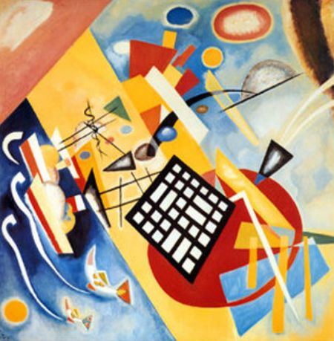
The school, called Das Bauhaus, was established in Weimar in 1919 by Walter Gropius and, having proved too radical for that city, moved to Dessau, where it continued until 1933, when it was closed by the Nazi government. Many of its staff emigrated to the United States, where they became important spokespersons for the Bauhaus philosophy. Universally, the Bauhaus has been recognized as the most influential institution of its type.

At the root of anything the Bauhaus did was “functionalism”, the theory that an object will automatically become attractive if it is designed to fulfill its purposes with maximum utility, ignoring all precedents and habits of construction. In traditional schools of architecture and design during the 1920s and 1930s students learned to imitate and modify existing forms from the distant and more recent past. However, students at the Bauhaus and its later offspring were given bizarre problems that challenged their imaginations and forced them to undertake experiments with basic materials. The austere and rather scientific logic of the Bauhaus approach tended to result in buildings, furniture, pictures, and posters that were spare, pristine, neat and rather anonymous.

Equally important with the Bauhaus in the establishment of Nordic Modern’s supremacy was the Swiss School, which in a complementary fashion began to reassess typography as a visual tool. Curlicues went out and bare-boned type came in. The absolute ultimate in no-nonsense lettering was a typeface that came to be called Helvetica (the Swiss name for Switzerland). It remains so today.

Popular Culture
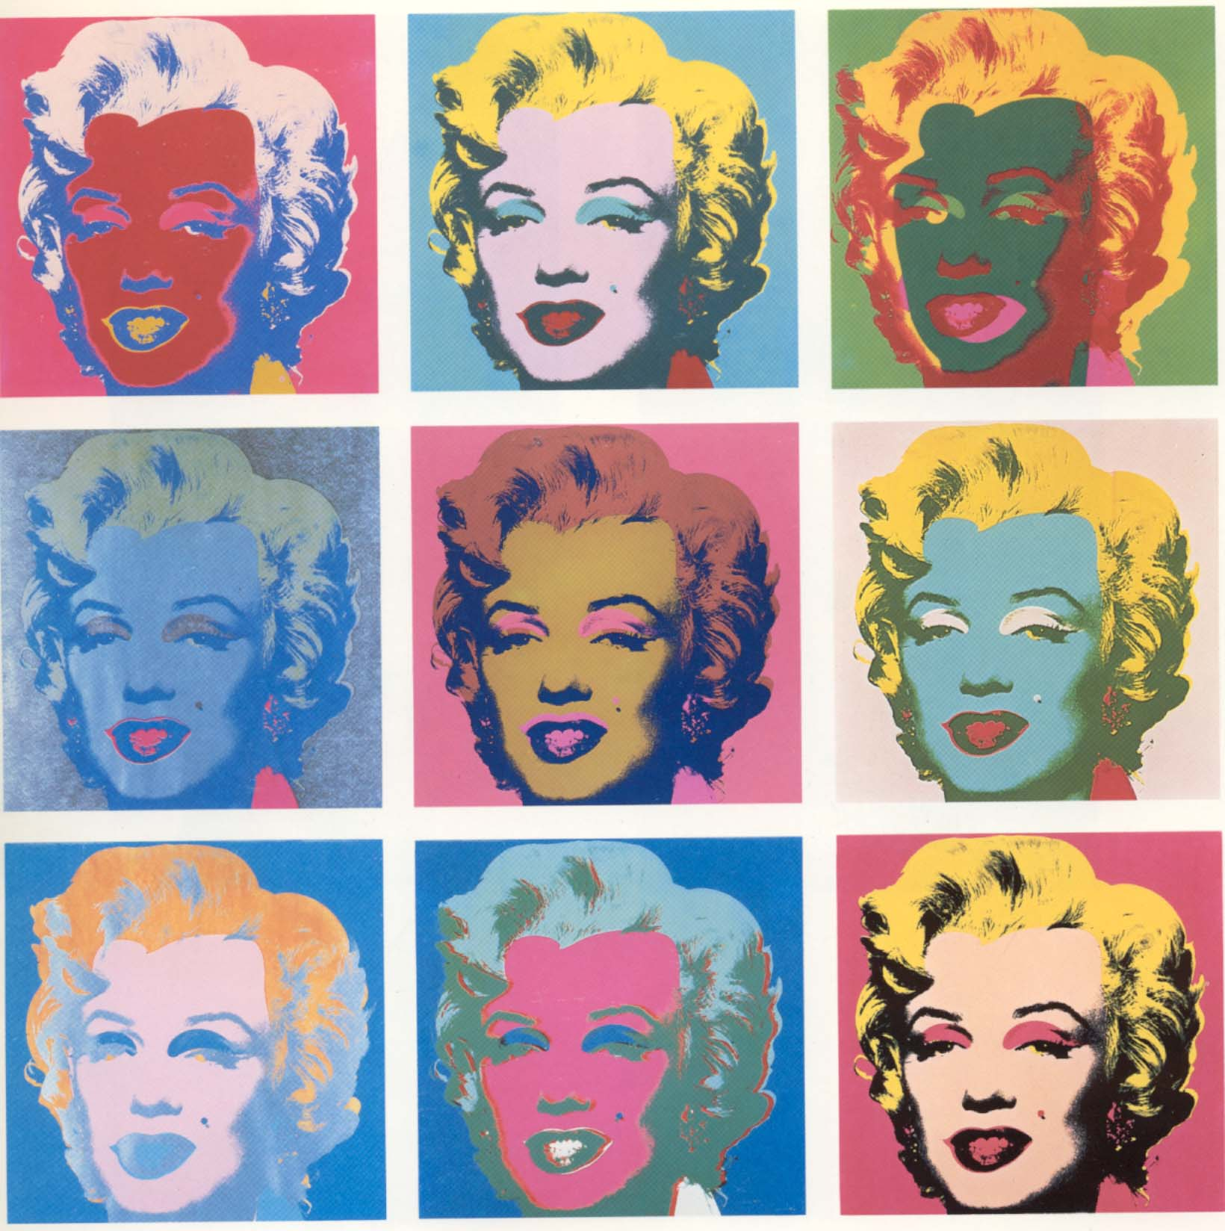
Toward the middle of the 20th century, artistic trends focused their attention on movements of urban popular culture or, rather, on the products of the consumer market that constituted the visual landscape of contemporary life. This was the movement known as Pop Art. The painters and sculptors who were part of this trend used popular images as subjects, for example characters from the movies or comic strips. Many of the most famous artists of this period moved from commercial illustration to Fine Art with hardly a change to their style or representation. This had an effect on the world of illustration, because it led to a re-evaluation of themes and styles that were commonly associated with less recognized genres. The new illustrator began to create versions of these popular forms and to experiment with formulas and techniques form other periods: old street advertisements, ancient typography, old movies and old photographs.

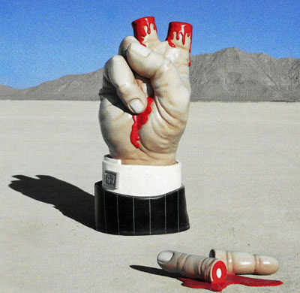
The Evolution of Graphic Design

Graphic design and illustration move in separate but parallel spheres, with the result that trends in one area always impacts on the other. This is logical since both disciplines inevitably co-exist on the same printed page. Illustrators have to be able to read the tendencies of the day, not just in illustrations produced by their contemporaries but in the specific aesthetic of graphic design, typography, use of space, colours, and so on.

Post Modernism

Push Pin Studio - a design firm founded by Symour Chwast and Milton Glaser, is the most prominent single representative of what has become the viable opposite extreme from Nordic Modern. Post Modern is a comparatively irreverent, cluttered and carefree style. It is a term that is still in fashion to describe a general reaction against the monumental solemnity and impersonality of Nordic Modern and modernism generally. In graphic design, Post Modernism deals in nostalgia, irony, exaggeration, and outright foolishness.

Open a word processor and answer the following questions using complete sentences.

Review Questions 16 Marks (Knowledge)

1. How did modern illustration begin?

2. Where can the origins of illustration be found?

3. Why were the medieval miniatures considered true works of art?

4. How was precision detail achieved in printing?

5. What did engraving allow artists to create?

6. What next great printing innovation was created in 1798? Why was it so great?

7. What was witnessed in the second half of the 19th century?

8. With whom did illustration reach a high point at the end of the 19th century and why?

9. What was the central core of the Victorian artist?

10. What does the term Nordic Modern cover?

11. What was at the root of Bauhaus?

12. How did the Swiss School reassess typography?

13. What is pop art known for?

14. What effect did Pop Art have on the world of illustration?

15. What was the single most representative of the opposite of Nordic Modern?

16. What kind of style is Post Modern?

Source: http://www.gallerywenzl.com/learningcentre/course%20files/tgj2/unit-2/1-historicaloverview.htm

